**Database Facebook project**

**Participations :-**

|  |  |
| --- | --- |
| ID | Name |
| 20221427861 | عبدالله حسين إبراهيم حسين محمد |
| 20221460231 | محمود عصام فتحي جبر |
| 20221369225 | زياد اشرف إبراهيم طاهر |
| 20221374025 | زياد أشرف حافظ جابر مصطفي |
| 20221374041 | عبدالرحمن اشرف رجب |

**ER Diagram :-**

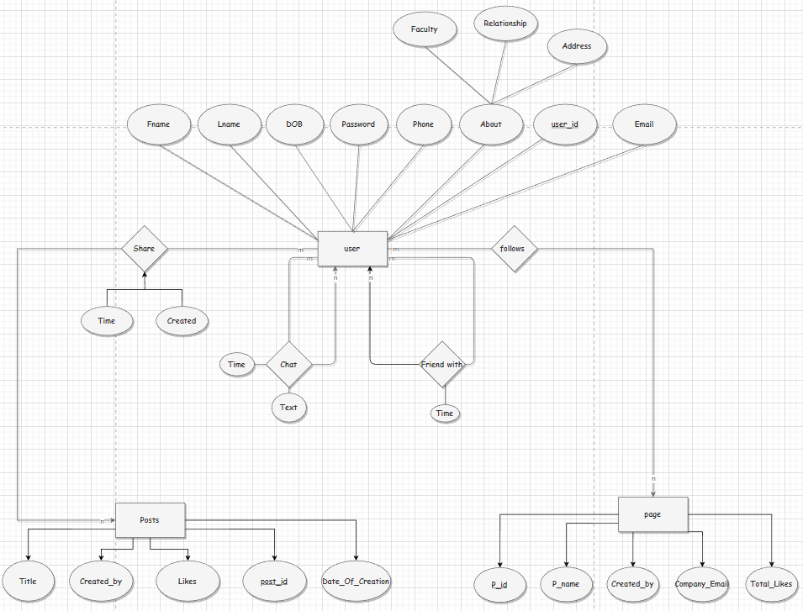

**Schema :-**

1-Entities

User(user_id,Fname,Lname,Date_of_Birth,Password,Phone,Faculty,Relationship,City)

Posts(post_id,likes,date_of_creation,created_by,title)

Page(company_Email,Page_date_of_creation,p_name,total_likes)

2-Relations

Chat(chat_id,user1_id,user2_id,text,time) “many to many Relation between user entity and itself such as : user1_id and user2_id are connected with FK to user_id in User entity,and chat_id is the primary key”

Friend_with(user1_id,user2_id,date)”many to many relation between user entity and itself such as : user1_id and user2_id are connected with FK to user_id in User entity”

Post(user_id,post_id,time)”many to many relation between User entity and Posts entity such that : user_id,post_id are composite primary keys connected with FK to User,Posts entites respectively”

follows(user_id,p_id)”many to many relation between User entity and Page entity such that : user_id and p_id are composite primary keys connected with FK to User , Page entities respectively”